Eventbrite Event Setup Guide
This guide will assist you in creating your ExpressTalks Celebrity Edition event on Eventbrite. You can create an Eventbrite account for free if you don’t already have one, and it’s free to use as long as it’s free for registrants to attend your event. If you decide to charge for your event, Eventbrite will charge you a percentage of your event’s ticket price. To calculate your potential earnings visit https://www.eventbrite.com/organizer/pricing/.
Eventbrite has numerous settings and promotional options that are not covered in this guide. If you need assistance in these additional options, visit https://www.eventbrite.com/support (U.S.) or https://www.eventbrite.ca/support?lg=en_CA (Canada).
It is recommended to have this guide open while creating your Eventbrite event so you can copy and paste content as needed.
View this page for an example event page.
Table of Contents
Basic Info 2
Details 4
Tickets 8
Publish 9
Order Options > Order Form 10
Order Options > Order Confirmation 13
Marketing > Email Invitations 15

Eventbrite Setup – Basic Info

Basic Info
Name your event and tell event-goers why they should come. Add details that highlight what makes it unique.
Event Title*(required)

Organizer
This profile describes a unique organizer and shows all of the events on one page.
Type
Category
Sub-category
Tags
Improve discoverability of your event by adding tags relevant to the subject matter.

bill_rancic
carla_harris
express_employment
leadership
leadership_development
motivational

Location
Help people in the area discover your event and let attendees know where to show up.

Venue
Online event
To be announced
Venue location
- Start typing in the location of your venue. The venue should automatically populate. If your venue populates, select the venue. If it does not populate, click on “Can’t find what you’re looking for? Add a new venue or address.” Then fill out the form.

Date and Time
Tell event-goers when your event starts and ends so they can make plans to attend.

Single Event
Recurring Events
A single event happens once and can last multiple days.
Event Starts*(required)
The scheduled date is April 21; however, you may host an event through May 21.
Start Time
Event Ends*(required)
End Time
Advanced Settings
Display start time.
The start time of your event will be displayed to attendees.
Display end time.
The end time of your event will be displayed to attendees.
Time Zone

Eventbrite Setup – Details

Main Event Image
This is the first image attendees will see at the top of your listing. Use a high quality image: 2160x1080px (2:1 ratio). – This image can be downloaded from MyDot on Feb. 15.

Main Event Image
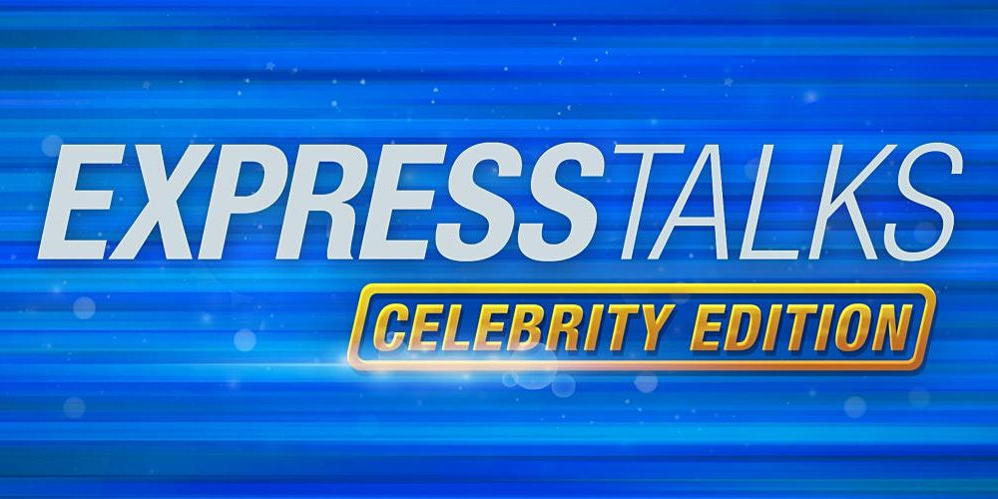

Description
Add more details to your event, like your schedule, sponsors, or featured guests.

Summary*(required)

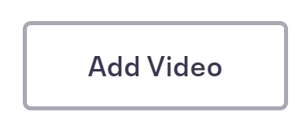

Video Link
- Promo video links can be found on MyDot. Promo videos will be available Jan. 20.

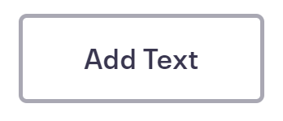
Bill Rancic
Entrepreneur, Award-Winning Author, and Motivational Speaker
Pause and Pivot to Elevate Your Business Above the Chaos
Bill Rancic will share why some companies thrive in chaos and others don't. He reveals what leadership behaviors are needed in a world beset by turbulence, uncertainty, and dramatic change. Bill will discuss his Pause and Pivot Method, a totally new technique teaching audiences how to evaluate their business procedures in a methodical manner that will make them more productive in both long- and short-term situations. Bill will share takeaways that are immediately applicable for anyone who wants to increase their return on investment, improve market share, or reap the benefits of a more productive, motivated workforce.
﻿Learn more about Bill Rancic.﻿
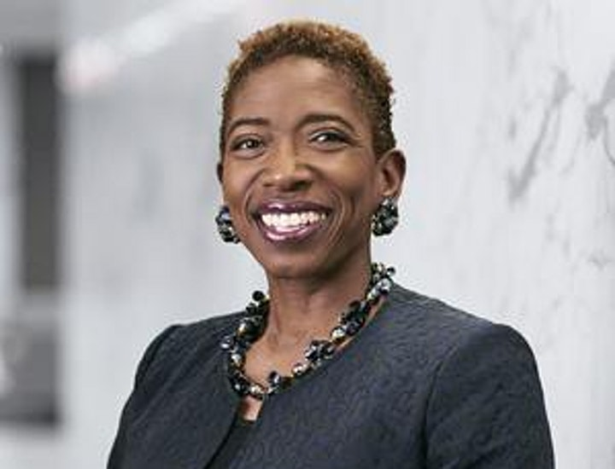

Carla Harris
Business Leader, Author, Keynote Speaker
Pearls of Wisdom to Ignite the Leader Within
Carla Harris’s passion lies in helping others. As she says, “we are blessed, so that we can be a blessing to others.” She vowed that when she reached senior management, she would provide people with the tools, strategies, and pearls of wisdom honed by her own experience. “Carla’s Pearls” include, Authenticity: The Power is You, The 90-Day Rule, Perception is the Co-Pilot to Reality, and many more.
﻿Learn more about Carla Harris.﻿

Eventbrite Setup – Tickets

Edit Ticket

Paid
Free
Donation
Name*(required)

Quantity*(required)
$ Price
Sales Start
Start Date*(required)
Start Time
Sales End*(required)
End Time
Advanced Settings
Description

Visibility
Tickets Per Order
Minimum Quantity*(required)
Maximum Quantity*(required)
Sales Channel
Delivery Method
eTicket
Will Call

Eventbrite Setup – Publish

Publish Your Event

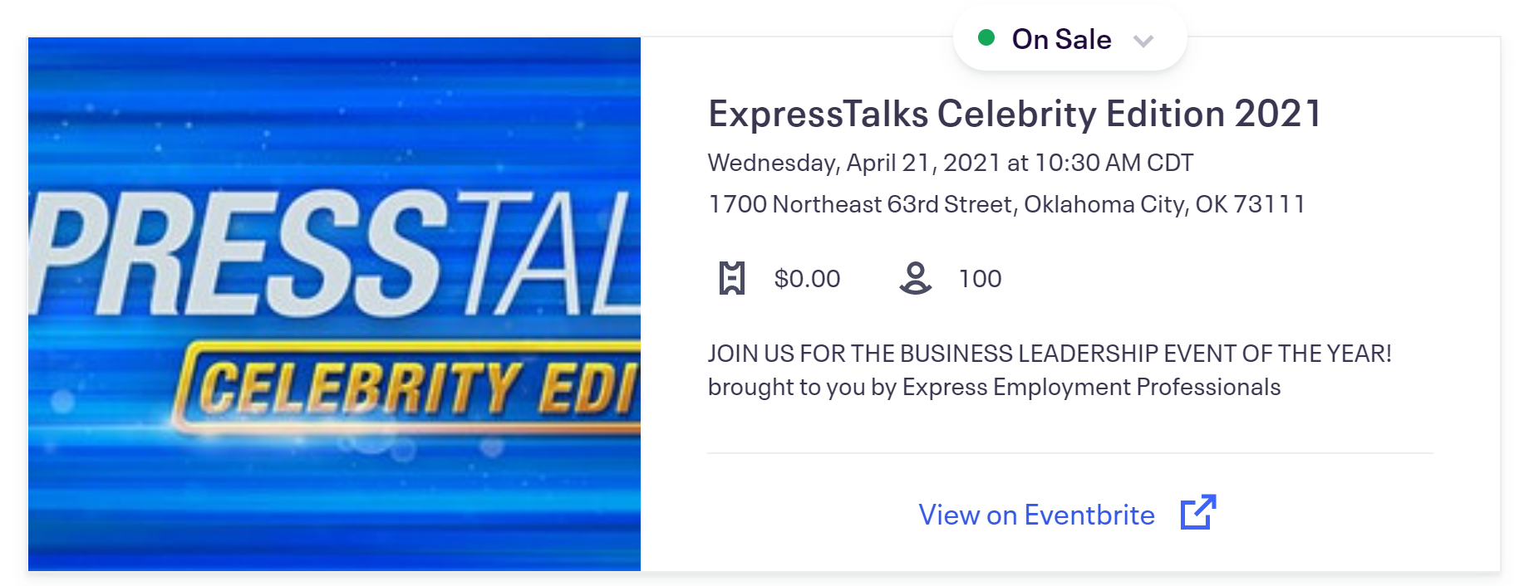
Who can see your event?
Public
Shared on Evenbrite and search engines

Private
Only available to a selected audience

Choose your audience
Audience

Eventbrite Setup – Order Options >

Order Form
Attendee Information
Email address, first name, last name, and payment information during checkout by are marked required default.
Collect information from each attendee

Collect attendee information on the following tickets
General Admission

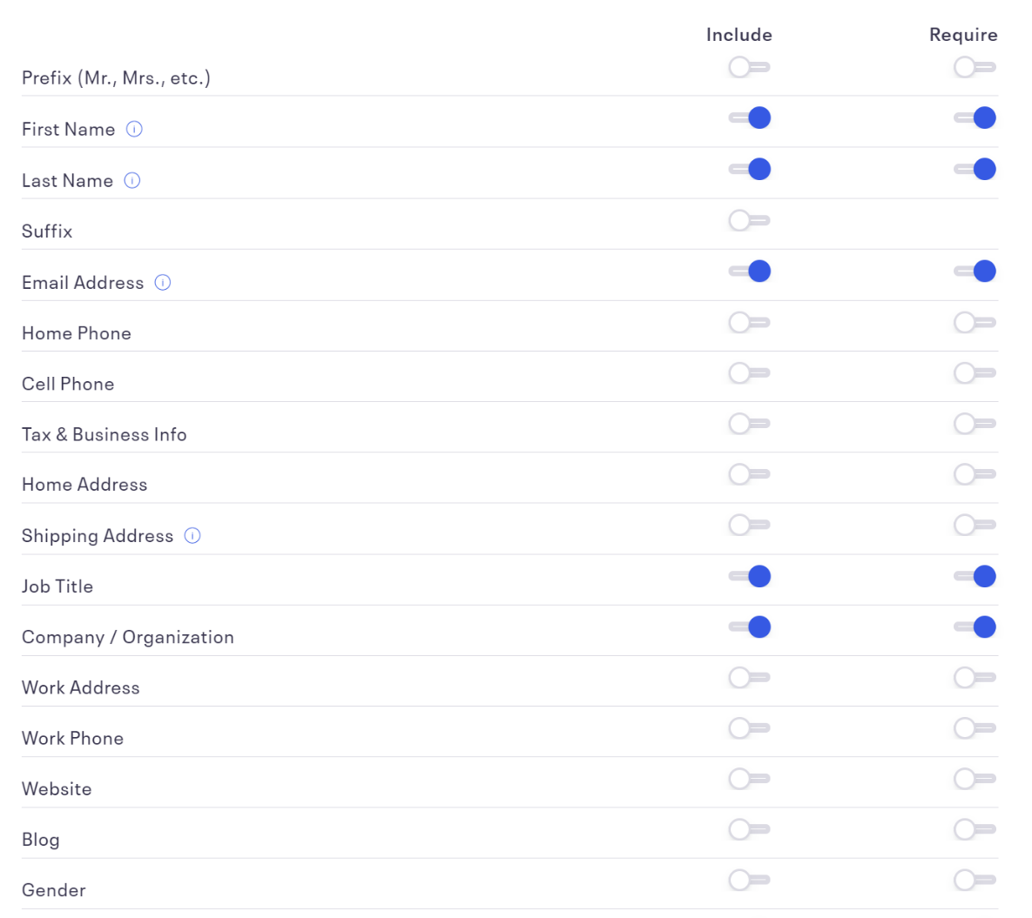
Information to collect: Choose from the following common questions or create a new question more specific to your needs.

Add custom question
Add the following suggested additional questions.
Do you make hiring decisions for your organization?
- Yes
- No

How many Express events have you attended? Please include any online events as well.
- This is my first Express Event
- 1 – 3
- 4 – 6
- 7 – 9
- 10+

This event is approved for 2 credit hours with SHRM/HRCI/HRPA/CPHR. Would you like a certificate of completion to collect your credit hours?
- Yes
- No

Group Registration - optional
Allow or require attendees to register as part of a group, team, organization, company, or association.
Activate Group Registration

Additional Items - optional
You can now create an unlimited amount of additional items, like merchandise or parking, under the Add-ons tab in the Tickets section. Fulfillment, shipping, and handling are still the responsibility of the event organizer.
Go To Tickets

Registration Options
Title For The Registration Page

Instructions For Your Attendees

Registration Time Limit
mins

Message To Display After Ticket Sales End

Eventbrite Setup – Order Options >

Order Confirmation

Customize Webpage

After registering for your event, attendees will see an onscreen message until they navigate away from the page. Add special instructions or other useful information here, but also add important information in the Customize Email section so the attendee can access it later.

Message For Order Confirmation Page (No Html Tags Allowed)

Customize Email

Your attendees will also receive an email after registration confirming their order. Add important instructions or other useful information here so attendees can access it at any time.

Default 'Reply-To' Email Address
First.last@expresspros.com

Message For Email And Printable PDF (If Included)

You have successfully registered for ExpressTalks Celebrity Edition.
Date: Wednesday, April 21, 2021
Time: 10:30 a.m. - 1 p.m.
Venue: National Cowboy and Western Heritage Museum
1700 Northeast 63rd St., OKC, OK 73111
Doors will open at 10 a.m. and the program will promptly begin at 10:30 a.m.
Lunch will be provided.
Questions or concerns regarding this event, please email first.last@expresspros.com.

Additional Settings

Configure whether attendees want to receive a printable PDF when they register.

Same settings for all ticket types

Printable Tickets - Optional

Include printable tickets in all orders

Eventbrite Setup – Marketing >
Email Invitations
Campaign Information

Campaign name*(required)
Subject*(required)
From*(required)
Reply-to email address*(required)
Header Image
The image appears in the content, above the content text. We recommend using at least a 2160x1080px (2:1 ratio) image that’s no larger than 10MB. – Add the ExpressTalks email header. Image can be downloaded from MyDot on Feb. 15.

Image alt text

Add text to make your image more accessible.
Image clickthrough URL
This is the URL your image will link to when the user clicks. – Use your Eventbrite event page link or leave this blank. Your event link can be found by clicking on Dashboard, then scrolling to the bottom to Your Links.

Body

Join us for the business leadership event of the year!

Wednesday, April 21, 2021 - 10:30 a.m.

Lunch will be provided.

Express Employment Professionals is excited to present two celebrity speakers known for their business acumen and decades of leadership experience.

Pause and Pivot to Elevate Your Business Above the Chaos

Featuring Bill Rancic - Entrepreneur, Award-Winning Author, and Motivational Speaker

Bill will share takeaways that are immediately applicable for anyone who wants to increase their return on investment, improve market share, or reap the benefits of a more productive, motivated workforce.

Pearls of Wisdom to Ignite the Leader Within

Featuring Carla Harris - Business Leader, Author, Keynote Speaker

Carla will provide the tools, strategies, and pearls of wisdom honed by her own experience. “Carla’s Pearls” include, Authenticity: The Power is You, The 90-Day Rule, Perception is the Co-Pilot to Reality, and many more.

Register soon because space is limited.

We hope you’re able to join us!

Choose your events
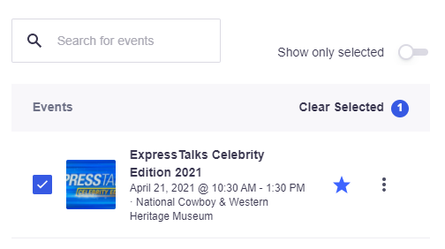
Footer
To help your email go through to inboxes instead of spam, the best practice is to have the following fields filled out.
Organizer name*(required)
Address 1*(required)
Address 2
City*(required)
State*(required)
ZIP Code*(required)
Country*(required)

Facebook link
Instagram link
Twitter link

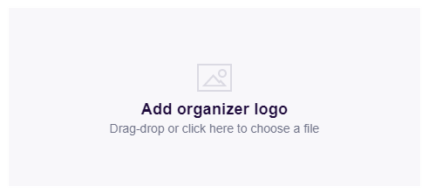 Add your Express logo.

