Canada Memo
Date: August 28, 2019
To: Express Employment Professionals
From: The Harris Poll
Subject: 2019 Survey of White Collar & Grey Collar Canadians

The survey was conducted online within Canada by The Harris Poll on behalf of Express Employment Professionals between June 18 and July 8, 2019 among 500 Canadian white collar workers (defined as adults ages 18+ who are employed full-time, part-time, or self-employed and works in an office, cubicle, or other administrative setting) and 507 grey collar workers (defined as adults ages 18+ who are employed full-time, part-time, or self-employed and works in one of the following professions: airline pilot or flight attendant, agribusiness professional (e.g., farmer, land manager), certified/licensed salesperson (e.g., real estate broker, stockbroker, insurance broker), clergy (e.g., minister, rabbi, imam), child care (e.g., nanny, au pair), engineer (e.g., mechanical, electrical, avionics, civil), firefighter, funeral director/technician, food preparation and catering (e.g., chef, sous chef), high-technology technician (e.g., lab technician, helpdesk technician, IT professional, medical equipment repair, solar panel installer), non-physician healthcare professional (e.g., nurse, emergency medical services personnel, physician’s assistant), paralegal, police officer, protective services, military, security or civil defense, professional musician/artist, school administrator, teacher, educator, or other academic field worker, or typist/stenographer). Results also were compared to a study conducted by The Harris Poll between July 9 and 23, 2018 among 520 blue collar workers in Canada who are employed full-time, part-time, or self-employed; performs work that requires manual labor; and works in one of the following industries: construction, manufacturing, transportation & warehousing, automotive services, maintenance, agriculture/ forestry/ fishing/hunting, or utilities.

Figures are weighted where necessary by age by gender, race/ethnicity, region, education, income, marital status, employment, household size, and propensity to be online to bring them into line with their actual proportions in the population.

All sample surveys and polls, whether or not they use probability sampling, are subject to multiple sources of error which are most often not possible to quantify or estimate, including sampling error, coverage error, error associated with nonresponse, error associated with question wording and response options, and post-survey weighting and adjustments. Therefore, The Harris Poll avoids the words “margin of error” as they are misleading. All that can be calculated are different possible sampling errors with different probabilities for pure, unweighted, random samples with 100% response rates. These are only theoretical because no published polls come close to this ideal.

Totals may not equal the sum of their individual components due to rounding.

Personal Optimism & Job Satisfaction is High

The majority of Canadian workers (white, 67%; grey, 67%; blue, 58%) are satisfied with their current lifestyle, and approximately 2 in 5 (blue, 41%; grey, 38%; white, 38%) believe they are better off now than they were five years ago. While worker satisfaction is notably high, a majority (blue, 75%; grey, 63%; white, 62%) say that life is a struggle.

Still, most workers are confident they will be able to reach their lifestyle goals (blue, 72%; grey, 70%; white, 69%), and when looking forward, the majority are optimistic about their future (white, 78%; grey, 77%; blue, 76%) and most parents believe their children will have a better future than they will (blue, 79%; white, 67%; grey, 65%). Most Canadian workers say their life is moving in the right direction, though white collar and grey collar workers are far more likely than blue collar workers to say this (white, 90%; grey, 87%; blue, 74%).

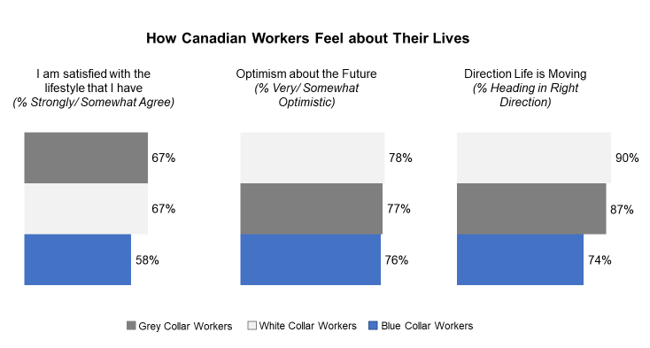

Grey collar workers are the most likely and blue collar workers are the least likely to say they are working in the field they expected to (grey, 47%; white, 37%; blue, 24%). Although there doesn’t appear to be one singular path to how workers get into their respective fields, for grey collar (32%) and white collar workers (26%) the most common reason by far is that they are interested in the field, less so for blue collar workers (14%). Only about 1 in 10 workers in Canada say their parent(s) had an influence over the type of work they currently do (blue, 12%; white, 11%; grey, 9%). And, if they had to do it all over again, the majority of grey collar and white collar workers would choose the same profession in which they are working now (grey, 71%; white, 69%).

How Workers First Became Interested in Their Field of Work (Top 3)
White Collar Workers | Grey Collar Workers | Blue Collar Workers
- Interested in the field (26%) | - Interested in the field (32%) | - Interested in the field (14%)
- It’s enjoyable (12%) | - It’s enjoyable (14%) | - It’s enjoyable (13%)
- Job security (10%)/ It was the only job that I could get (10%) | - Job security (9%) | - It is profitable (12%)/ Other members of my family are in this line of work (12%)

The majority of workers in Canada like their job (grey, 68%; blue, 63%; white, 61%) and are at least somewhat satisfied with it (blue, 85%; grey, 84%; white, 82%) and proud of the work they do (blue, 88%; grey, 88%; white, 83%). Most also believe their job provides a good living to financially support their family (white, 76%; blue, 73%; grey, 72%), and few see their job as potentially at risk, with only a minority worrying they might lose it in the near future (grey, 18%; white, 16%; blue, 12%).

Continuing the positive sentiment, most Canadian workers believe their employer cares about its employees (white, 73%; blue, 71%; grey, 67%). More than half of white collar workers say their company treats them fairly, though grey collar and blue collar workers are less likely to feel the same way (white, 56%; grey, 44% blue, 42%). While many workers describe their boss as “great” (white, 41%; grey, 38%; blue, 29%), white collar workers are more likely than grey collar workers to say their boss cares about them personally (white, 77%; grey, 68%). Few white collar or grey collar workers feel empowered to negotiate their salary or wage (white, 14%; grey, 13%), and over half of grey collar workers specifically (58%) say having a union would be helpful (far fewer white collar workers (42%) feel the same way).

The top attributes that workers appreciate about their jobs vary, though “making a good living wage” is noted by close to half of all workers (white, 51%; blue, 47%; grey, 44%).

Top 3 Attributes Workers Like About Their Job Field/Occupation
White Collar Workers | Grey Collar Workers | Blue Collar Workers
- Making a good living wage (51%) | - Being able to help others/ Having a sense of purpose (54%) | - Making a good living wage (47%)
- It is not dangerous (50%) | - Making a good living wage (44%) | - Being challenged by the type of work I do (44%)
- Flexible work hours (45%) | - Being challenged by the type of work I do (41%) | - Flexible work hours (39%)/ low likelihood of being replaced by automation (39%)

On the other hand, the most common traits that workers say they dislike about their job include: limited/no advancement opportunities, little to no flexibility in work hours, and not making a good living wage. This aligns with the top concerns that workers have about their workplace, with many saying being paid well (white, 26%; grey, 26%; blue, 26%) and no advancement opportunities (white, 30%; grey, 24%; blue, 22%).

Top 3 Attributes Workers Dislike About Their Job Field/Occupation
White Collar Workers | Grey Collar Workers | Blue Collar Workers
- Limited/no advancement opportunities (33%) | - Limited/no advancement opportunities (30%) | - It can be dangerous at times (33%)
- Little to no flexibility in work hours (18%)/ Type of work that I do is not challenging (18%) | - Little to no flexibility in work hours (24%) | - Limited/no advancement opportunities (29%)
- Not making a good living wage (15%) | - Not making a good living wage (22%) | - Not making a good living wage (22%)

Outlook on Personal Job is Positive

A majority of workers say it is easy to find a job in their field right now (blue, 66%; white, 57%; grey, 52%) and that there is a good career path in their line of work (grey, 70%; blue, 68%; white, 67%). Many agree that more young men (grey, 67%; white, 64%; blue, 64%) and young women (grey, 70%; white, 69%; blue, 51%) should pursue careers in their field. In addition, more than half of workers would be at least somewhat likely to encourage a friend/family member (grey, 62%; white, 59%; blue, 55%) or child (grey, 58%; white, 54%; blue, 43%) to pursue a career in their line of work. For those who would encourage a child to pursue the same career, the reasons for doing so are predominantly because it’s enjoyable (grey, 63%; white, 49%; blue, 42%), it pays well (blue, 49%; white, 43%; grey, 37%), and job security (grey, 43%; white, 43%; blue, 40%).

When thinking about the future, about a quarter of grey collar (25%) and white collar workers (24%) believe in 5 years there will be a greater number of jobs in Canada that are “grey collar”. And, some workers believe there will be more jobs available in their field in the coming decade, particularly grey collar workers (grey, 27%; white, 19%).

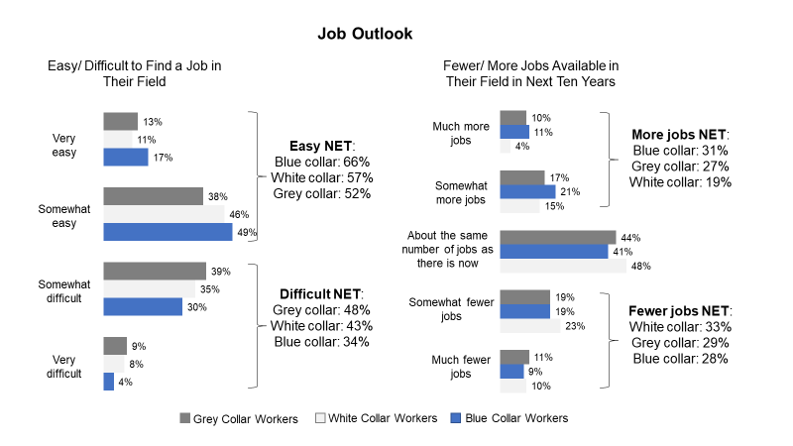
That said, a significant minority of workers say having their type of job is less respected now than it was 10 years ago (grey, 45%; white, 39%). Still, blue collar workers are more likely than grey collar and white collar workers to feel like society generally looks down on their line of work (blue, 49%; grey, 31%; white, 24%) and that at times, they are viewed as second-class citizens because of the type of work that they do (blue, 47%; white, 28%; grey, 26%). For those who would not encourage a child to pursue a career in the same industry, the main reasons are lack of advancement opportunities (grey, 40%; white, 39%; blue, 39%), long hours (blue, 40%; grey, 22%; white, 19%), and high performance demands (blue, 32%; white, 28%; grey, 23%).

Moreover, many Canadian workers say it is easy for their employer to find cheaper labor to do their job, especially blue collar workers (blue, 46%; white, 39%; grey, 33%). Blue collar workers also are far more likely than white collar and grey collar workers to say illegal immigrants make it harder for them to get a job in their field (blue, 31%; white, 23%; grey, 18%) and allow their employer to pay them less money to do their job (blue, 31%; white, 20%; grey, 17%).

Financial Status – Strong Majority Concerned About Retirement, Less than Half Have at Least $5k Saved for Emergency

Approximately half of Canadian workers describe themselves as middle income (white, 56%; grey, 53%; blue, 47%), though white collar and grey collar workers are more likely than blue collar workers to lean slightly toward upper or upper middle class (white, 25%; grey, 22%; blue, 14%). Roughly 8 in 10 workers say they are able to make ends meet (white, 83%; grey, 82%; blue, 77%), with white collar workers the most likely and blue collar workers the least likely to say it is easy for them to make ends meet (white, 60%; grey, 53%; blue, 44%).

The majority of workers, less so blue collar, received a pay increase in the past year (white, 63%; grey, 63%; blue, 55%) and anticipate that they will receive another pay increase this coming year or the following year (white, 58%; grey, 53%; blue, 51%). In the past year, many workers received increased responsibilities in the workplace (white, 53%; grey, 47%; blue, 42%), but far fewer (more white collar) received a promotion (white, 32%; grey, 24%; blue 24%).

Half of Canadian workers feel they are in a similar place financially compared to their neighbors (white, 50%; blue, 50%; grey, 47%). Many say they are financially better off than their parents were at the same age (white, 41%; grey, 41%; blue, 33%) and many parents expect that their kids will be financially better off than they are now, particularly blue collar workers (blue, 58%; grey, 46%; white, 40%).

When it comes to their actual finances, about half or more (blue, 63%; grey, 46%; white, 44%) have less than $5K saved to use in the event of an emergency, with nearly 1 in 5 blue collar workers (17%) and 1 in 10 grey collar (12%) and white collar workers (9%) having nothing at all saved. And, the majority of Canadian workers are worried about saving enough for their retirement (white, 69%; grey, 69%; blue, 68%). Despite high concern, less than half of workers are currently setting aside money for their retirement, with blue collar workers the least likely to say they are doing so (white, 45%; grey, 45%; blue, 31%).
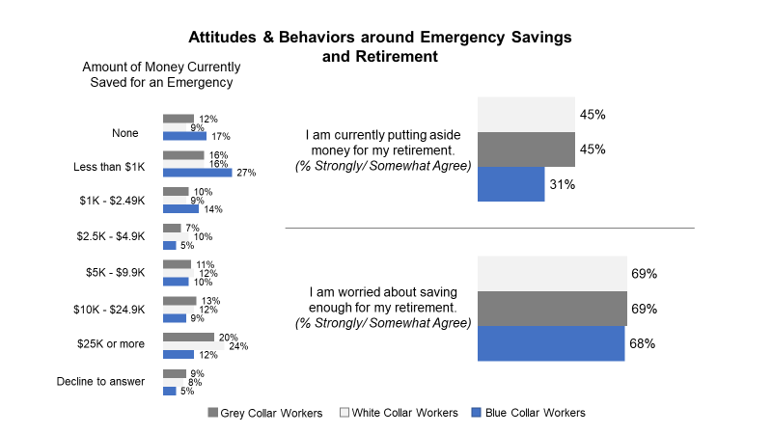

College Degree Worth It, But Significant Minority Worried About College Debt

Among those with a high school degree or less, over half look back and wish they had chosen to attend community college, 4-year college, or vocational school (white, 64%; grey, 56%; blue, 51%). Further, white collar and blue collar workers are more likely than grey collar workers to say they would have had more opportunities available if they had instead decided to go to college (white, 74%; blue, 74%; grey, 57%).

The vast majority of college-educated grey collar and white collar workers say that the education that they received is at least somewhat helpful to the job they currently have (grey, 89%; white, 87%), with more than 1 in 4 saying it was absolutely essential (white, 30%; grey, 28%). In fact, most college graduates (grey, 83%; white, 80%) say going to college was worth every penny. At least 3 in 4 Canadian workers (white, 79%; grey, 78%) believe people who pursue specialized education will be more appealing job candidates, and around 7 in 10 (grey, 72%; white, 71%) believe specialized professional degrees/diplomas provide workers with the best “bang for their buck.”

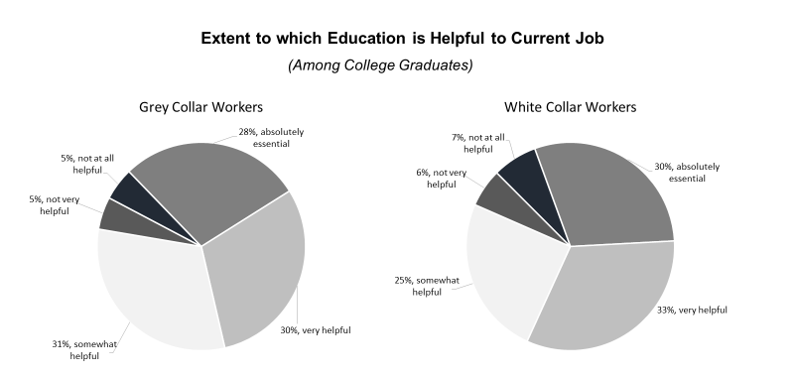

Still, some college-educated workers wish they had gone to community college, vocational school or straight into the workforce instead of getting a college degree (white, 29%; grey, 23%). Nearly 1 in 5 say they have too much student debt from going to college (white, 19%; grey, 17%) and cannot find a good job despite their college degree (grey, 26%; white, 24%). In fact, for those who attended vocational school or college, 1 in 5 currently have student loan debt (grey, 21%; white, 20%), estimating it will take approximately 5-6 years on average to pay off.

Political Scan – Affordability, Economy, Healthcare Top List of Concerns; Nearly Half Say PM Not Doing a Good Job & Country in Headed in Wrong Direction

While the majority of workers believe that their local community is heading in the right direction (white, 75%; blue, 73%; grey, 70%), much fewer say their province (white, 56%; grey, 52%; blue, 52%) or their country (white, 56%; grey, 56%; blue, 54%) is heading in the right direction.

For Canadian grey collar and white collar workers, the top concerns heading into the 2019 Federal Election in Canada are: healthcare (grey, 64%; white, 55%), the affordability of daily living (grey, 57%; white, 57%), and the economy (white, 56%; grey, 55%). Likewise, at least a quarter of Canadian workers are very worried about each of the following issues: affordability of daily living (grey, 49%; white, 43%), healthcare (grey, 40%; white, 34%), climate change (grey, 33%; white, 30%), and the economy (grey, 31%; white, 26%).

Canadian white collar (54%) and grey collar workers (49%) are more likely than blue collar workers (43%) to describe the provincial government as pro-business, but all collar types appear torn as to which political party does a better job of helping Canadians in their line of work, with workers fairly split on whether the Conservative Party (white, 27%; blue, 25%; grey, 22%), New Democratic Party (blue, 22%; grey, 14%; white, 13%), or Liberal Party (white, 26%; grey, 22%; blue, 19%) does a better job.

When it comes to the Prime Minister, close to half of Canadian grey collar and white collar workers (grey, 49%; white, 46%) disapprove of the job that he is doing, compared to 42% of blue collar workers who disapprove; roughly a quarter of workers approve of the job the PM is doing (grey, 26% blue, 24%; white, 23%); and the remainder say they neither approve or disapprove (blue, 34%; white, 31%; grey, 24%). In addition, workers are split on whether the Prime Minister has hurt (grey, 33%; blue, 27%; white, 26%), helped (blue, 20%; grey, 18%; white, 15%) or neither helped nor hurt their industry (white, 59%; blue, 53%; grey, 49%).

Worker Profile – Blue, white, and grey collar workers in Canada work fairly similar number of hours; pay structure and work location vary.

Workers in Canada have generally been part of the workforce for over two decades (blue, 25 years; white, 22 years; grey, 22 years) and employed in their current job for about half that time (blue, 11 years; white, 10 years; grey, 10 years), on average. For Canadian employees, the workweek hovers around 40 hours per week, though higher for blue collar and lower for grey collar workers (blue, 39 hours/week; white, 38 hours/week; grey, 36 hours/week).

The vast majority of white collar (94%) and grey collar workers (80%) work mostly indoors, compared to 51% of blue collar workers who say the same. When it comes to pay, the majority of white collar workers (65%) are salaried, while most blue collar workers (76%) and more than half of grey collar workers (55%) receive an hourly wage.

Technology plays an important role for some, though more so for white collar and grey collar than blue collar workers. White collar and grey collar workers are far more likely than blue collar workers to say using technology is a significant part of their job (white, 53%; grey, 39%; blue, 13%), and their job is in the technology sector (grey, 20%; white, 14%; blue, 5%).

